REFUTE IT / 23.10 – 15.11.2014

metamatic:taf has the pleasure to present the exhibition REFUTE IT which opens on Thursday 23 October 2014 at 20.30 and will run until Saturday 15 November.

Ten comic book artists and four scriptwriters from the contemporary Greek comic scene stand against the present social condition and choose a word, which according to them reflects contemporary life, in order to produce a work based on it. All the words arising have a negative connotation: Dissension (Διαίρεση), Fanaticism (Iδεοληψία), Low Spirit (Ακεφιά), Lie (Ψέμα), Egoism (Εγωισμός), Hypocrisy (Υποκρισία), Decay (Σήψη), Obsession (Εμμονή), Humiliation (Ταπείνωση) and Rage (Οργή). Their negativity will be reversed soon; the first letter of each word in Greek eventually forms an acrostic which constitutes the title of the exhibition, while being a direct challenge to the public: REFUTE IT (ΔΙΑΨΕΥΣΕ ΤΟ).

Drawing inspiration from John Dewey’s popular quote claiming that “a problem well defined is half solved”, the participating artists compel the visitor to a full consciousness of reality. Each of the words and by extension their semantic content is presented in a raw, divested or even pretentiously harsh way both in their meaning and in their consequences and extensions. Through the multilevel art of comics that combines the undeniable influence of the image with a minimal yet substantial text, the artists are trying to provoke emotional reactions and ultimately transform them into thoughts, concerns, ideals and above all actions which will go beyond the limited grounds of metamatic:taf’s exhibition space.

At the same time the artists introduce themselves, being exposed along with their works, while opening an interactive dialogue with the public. They willingly accompany the visitors from the first reaction or aversion to the acceptance and awareness of the problem.

Each and every creator puts their personal signature using their own techniques and experiences, utilising an arsenal of pencils, inks, watercolours, ecoline and acrylics. Students and teachers, professionals and amateurs from different backgrounds and with different means of expression, unite under the art of comics, striving, venturing, educing or provoking: REFUTE IT.

On Saturday 15 November at 19:00, on the occasion of the exhibition closing, metamatic:taf will host a live music show by the band Happy Dog Project.

Paricipating artistis: Katerina Bakagianni, Manolis Frangidis, Valia Kapadai, Vera Kartalou, Eugenia Koumaki, Giannis Monogyios, Kostas Pantoulas, Pavlos Pavlidis, Fotis Pehlivanidis, Thanasis Petrou, Konstantinos Sklavenitis, Sophia Spirliadou, Panagiotis Tsaousis, Angeliki Tzortzakaki, Kostis Tzortzakakis, Dimitris Vanellis, Martha Vosdou, Klio Xenidou

Curated by: Vera Kartalou

Opening: Thursday 23 Οctober 2014, 20:30
Exhibition duration: 23.10 – 15.11.2014
Opening hours: Mon-Sat 12.00-21.00, Sun 12.00-19.00

Happy Dog Project live: Saturday 15.11.2014, 19.00

Admission Free

Event communication contributors

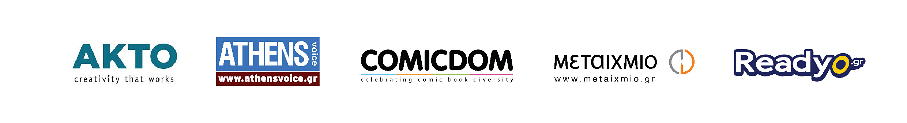

Event contributors
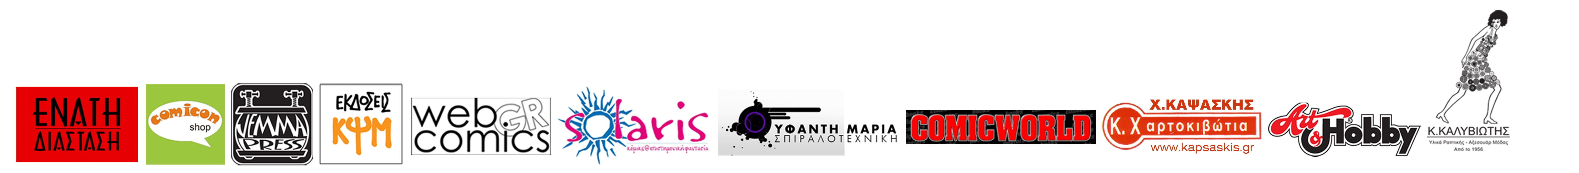

For more information:
http://theartfoundation.metamatic.gr/EN/Event/2701/REFUTE_IT/

-------------------------------------------------------------------------------------------------------------------------------------------
About metamatic:taf

metamatic:taf (The Art Foundation) is an organisation which since 2009 operates as an independent establishment implementing and hosting cultural events related to all forms of artistic production. It is an open space for social gathering and discourse, available and accessible to the public during the entire year, seven days a week (min 200,000 visitors per year). It is a platform for the exchange of current ideas and practices, where thought is not being separated from action and culture is conceived as an everyday actuality, offering a complete artistic, educative and recreational experience. Since September 2012, TAF/The Art Foundation has been renamed to metamatic:taf expanding its activities to the on-line environment through the internet platform www.metamatictaf.gr, which operates as an extension of its practices addressed to both a greek and english speaking public. The electronic space of metamatic:taf has kept the orientation of Normanou’s physical space but at the same time it has been receiving feedback from a number of additional complex considerations and issues related to the on-line endeavour. The promotion of the events hosted at the physical space is only but a small part of the website’s content; its main corpus aims to contribute to the formation of an active communication platform where disparate practices will converge and interact in the digital environment. For more information about metamatic:taf please visit http://theartfoundation.metamatic.gr/GR/about_metamatic_taf/. For more information please contact, regarding the exhibition space Iphigenia Papamikroulea, Christina Dilari and Yalena Kleidara at +30 210 3238757 or via email at info@metamatictaf.gr.

